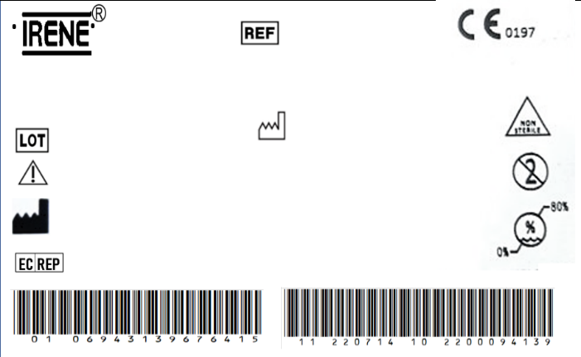

DIAMOND™ Co-Cr-Mo Bipolar Head

C30410041

2300038656

4/22/2023

REGISTRO SANITARIO

5877-DME-1118

IMPORTADO Y DISTRIBUIDO POR ORTOMAX- PINEDA CORAL JAIRO DARIO

The implante should be sterilized before surgery.

TianJin ZhengTian Medical Instrument Co., ltd.

No. 318, Jingyi Road

Airport Economic Zone 300308 TianJin P.R. China

Bricon GmbH

EisenBahnstrasse 100, 78573 Wurmlingen, Germany

4/21/2028

Spec

41# (Φ41/Φ24)



DIAMOND™ Co-Cr-Mo Bipolar Head

C30410041

2300038656

4/22/2023

REGISTRO SANITARIO

5877-DME-1118

IMPORTADO Y DISTRIBUIDO POR ORTOMAX- PINEDA CORAL JAIRO DARIO

The implante should be sterilized before surgery.

TianJin ZhengTian Medical Instrument Co., ltd.

No. 318, Jingyi Road

Airport Economic Zone 300308 TianJin P.R. China

Bricon GmbH

EisenBahnstrasse 100, 78573 Wurmlingen, Germany

4/21/2028

Spec

41# (Φ41/Φ24)



DIAMOND™ Co-Cr-Mo Bipolar Head

C30410041

2300038656

4/22/2023

REGISTRO SANITARIO

5877-DME-1118

IMPORTADO Y DISTRIBUIDO POR ORTOMAX- PINEDA CORAL JAIRO DARIO

The implante should be sterilized before surgery.

TianJin ZhengTian Medical Instrument Co., ltd.

No. 318, Jingyi Road

Airport Economic Zone 300308 TianJin P.R. China

Bricon GmbH

EisenBahnstrasse 100, 78573 Wurmlingen, Germany

4/21/2028

Spec

41# (Φ41/Φ24)



DIAMOND™ Co-Cr-Mo Bipolar Head

C30410041

2300038656

4/22/2023

REGISTRO SANITARIO

5877-DME-1118

IMPORTADO Y DISTRIBUIDO POR ORTOMAX- PINEDA CORAL JAIRO DARIO

The implante should be sterilized before surgery.

TianJin ZhengTian Medical Instrument Co., ltd.

No. 318, Jingyi Road

Airport Economic Zone 300308 TianJin P.R. China

Bricon GmbH

EisenBahnstrasse 100, 78573 Wurmlingen, Germany

4/21/2028

Spec

41# (Φ41/Φ24)



DIAMOND™ Co-Cr-Mo Bipolar Head

C30410041

2300038656

4/22/2023

REGISTRO SANITARIO

5877-DME-1118

IMPORTADO Y DISTRIBUIDO POR ORTOMAX- PINEDA CORAL JAIRO DARIO

The implante should be sterilized before surgery.

TianJin ZhengTian Medical Instrument Co., ltd.

No. 318, Jingyi Road

Airport Economic Zone 300308 TianJin P.R. China

Bricon GmbH

EisenBahnstrasse 100, 78573 Wurmlingen, Germany

4/21/2028

Spec

41# (Φ41/Φ24)



DIAMOND™ Co-Cr-Mo Bipolar Head

C30410041

2300038656

4/22/2023

REGISTRO SANITARIO

5877-DME-1118

IMPORTADO Y DISTRIBUIDO POR ORTOMAX- PINEDA CORAL JAIRO DARIO

The implante should be sterilized before surgery.

TianJin ZhengTian Medical Instrument Co., ltd.

No. 318, Jingyi Road

Airport Economic Zone 300308 TianJin P.R. China

Bricon GmbH

EisenBahnstrasse 100, 78573 Wurmlingen, Germany

4/21/2028

Spec

41# (Φ41/Φ24)



DIAMOND™ Co-Cr-Mo Bipolar Head

C30410041

2300038656

4/22/2023

REGISTRO SANITARIO

5877-DME-1118

IMPORTADO Y DISTRIBUIDO POR ORTOMAX- PINEDA CORAL JAIRO DARIO

The implante should be sterilized before surgery.

TianJin ZhengTian Medical Instrument Co., ltd.

No. 318, Jingyi Road

Airport Economic Zone 300308 TianJin P.R. China

Bricon GmbH

EisenBahnstrasse 100, 78573 Wurmlingen, Germany

4/21/2028

Spec

41# (Φ41/Φ24)



DIAMOND™ Co-Cr-Mo Bipolar Head

C30410041

2300038656

4/22/2023

REGISTRO SANITARIO

5877-DME-1118

IMPORTADO Y DISTRIBUIDO POR ORTOMAX- PINEDA CORAL JAIRO DARIO

The implante should be sterilized before surgery.

TianJin ZhengTian Medical Instrument Co., ltd.

No. 318, Jingyi Road

Airport Economic Zone 300308 TianJin P.R. China

Bricon GmbH

EisenBahnstrasse 100, 78573 Wurmlingen, Germany

4/21/2028

Spec

41# (Φ41/Φ24)



DIAMOND™ Co-Cr-Mo Bipolar Head

C30410041

2300038656

4/22/2023

REGISTRO SANITARIO

5877-DME-1118

IMPORTADO Y DISTRIBUIDO POR ORTOMAX- PINEDA CORAL JAIRO DARIO

The implante should be sterilized before surgery.

TianJin ZhengTian Medical Instrument Co., ltd.

No. 318, Jingyi Road

Airport Economic Zone 300308 TianJin P.R. China

Bricon GmbH

EisenBahnstrasse 100, 78573 Wurmlingen, Germany

4/21/2028

Spec

41# (Φ41/Φ24)



DIAMOND™ Co-Cr-Mo Bipolar Head

C30410041

2300038656

4/22/2023

REGISTRO SANITARIO

5877-DME-1118

IMPORTADO Y DISTRIBUIDO POR ORTOMAX- PINEDA CORAL JAIRO DARIO

The implante should be sterilized before surgery.

TianJin ZhengTian Medical Instrument Co., ltd.

No. 318, Jingyi Road

Airport Economic Zone 300308 TianJin P.R. China

Bricon GmbH

EisenBahnstrasse 100, 78573 Wurmlingen, Germany

4/21/2028

Spec

41# (Φ41/Φ24)